Named routes

Workshop #03

Flutter Developer Bootcamp

# **Purpose**

This workshop demonstrates how to navigate screens with named routes.

# **Problem**

In the provided workshop, you want to create a settings button. When the user clicks on the button, it will navigate to the settings screen using named routes. The button must be blue, and the settings screen must include a "go back" button to return to the home screen. The app bar of the settings screen must be blue, and the "go back" button should also be blue.

# **How to Solve**

1. Checkout the workshop from Git Repo:

git clone -b <user-branch> <repo-URL>

2. Open the root folder inside VS Code

3. To build the app click the run option in the main method { }

4. Create a settings button on the home screen and navigate to the settings screen using named routes.

# **You Will Achieve**

At the completion of the workshop, you'll learn how to use named routes to navigate between screens.

# **Screenshots**

## **Before implementation (without Settings screen)**

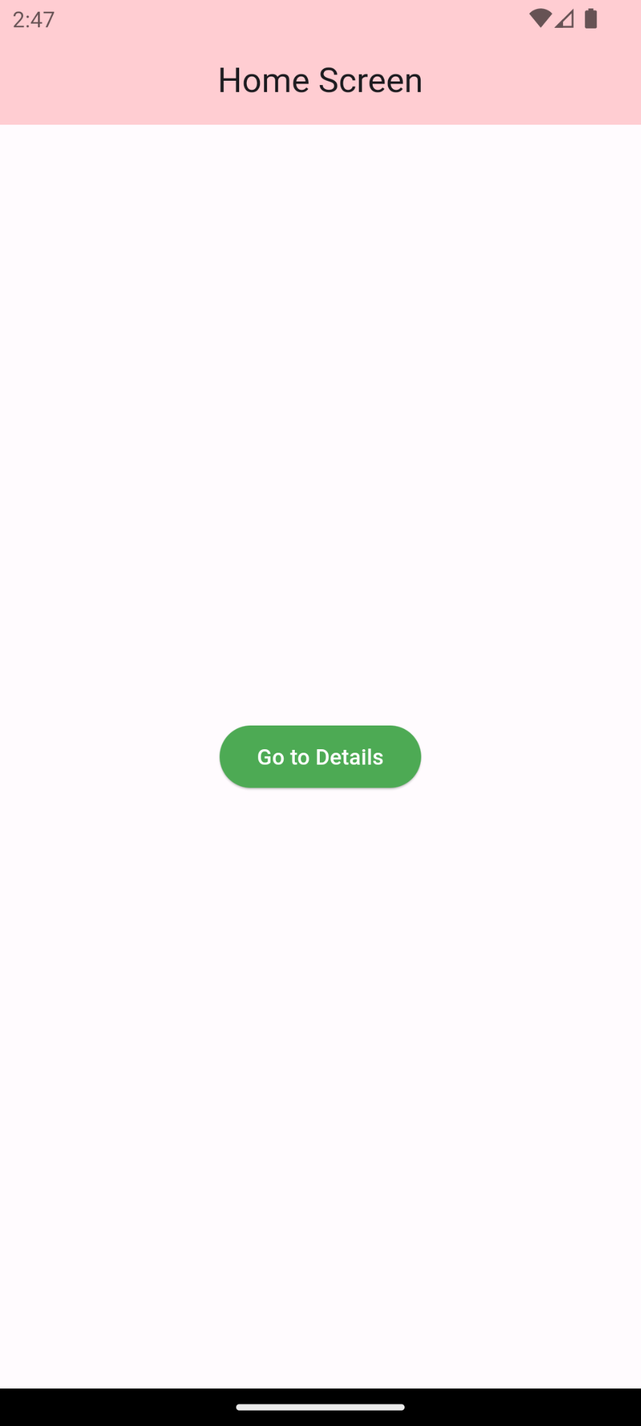 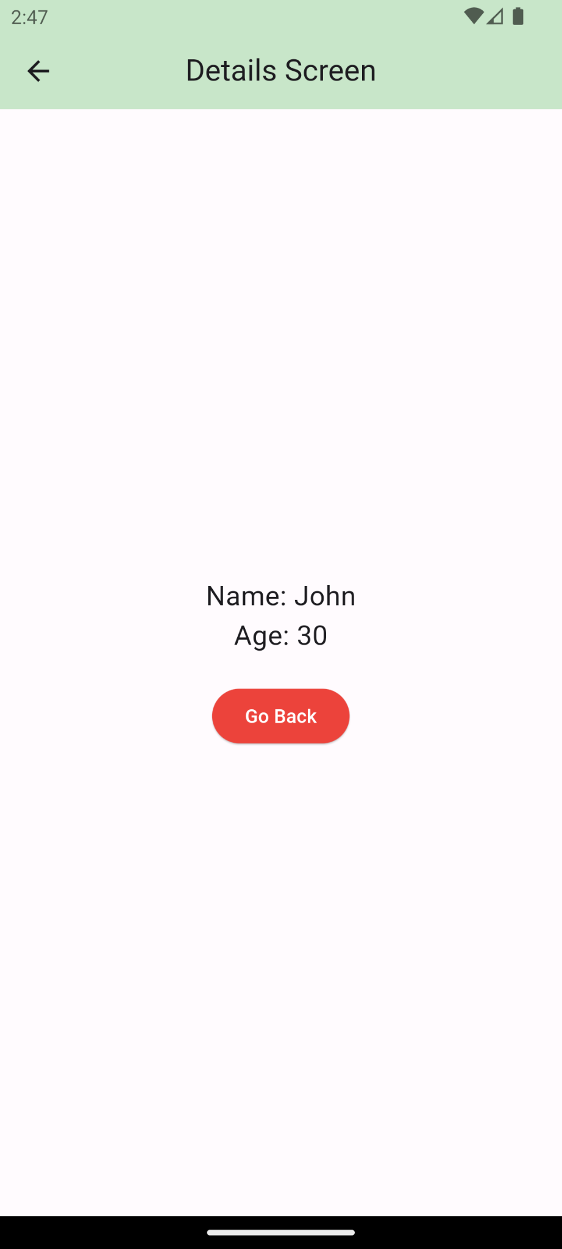

## **After implementation (With Settings screen)**

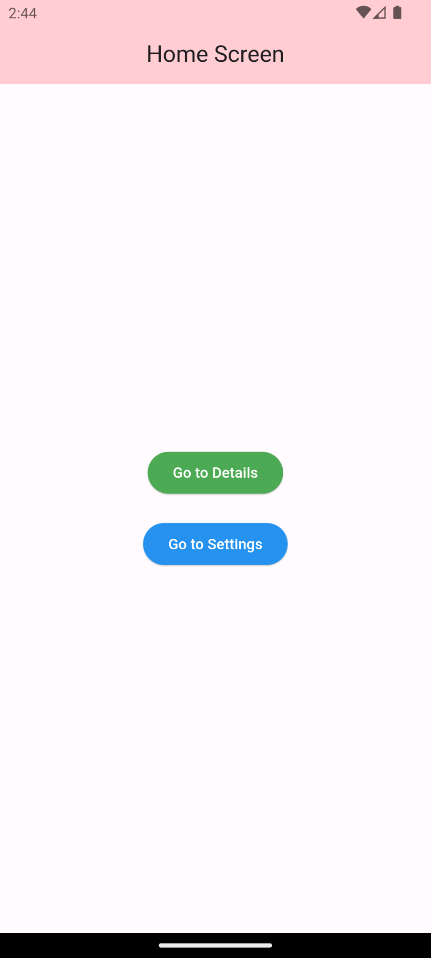 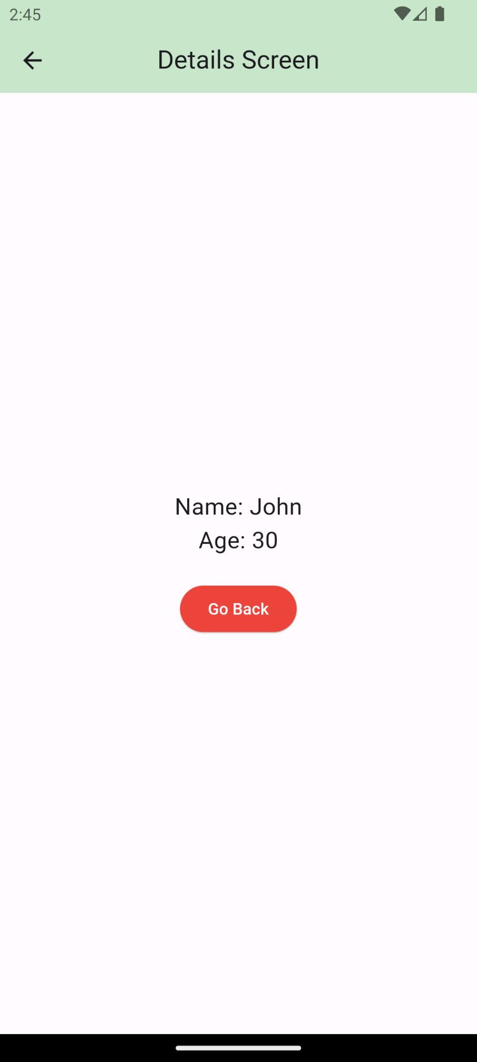 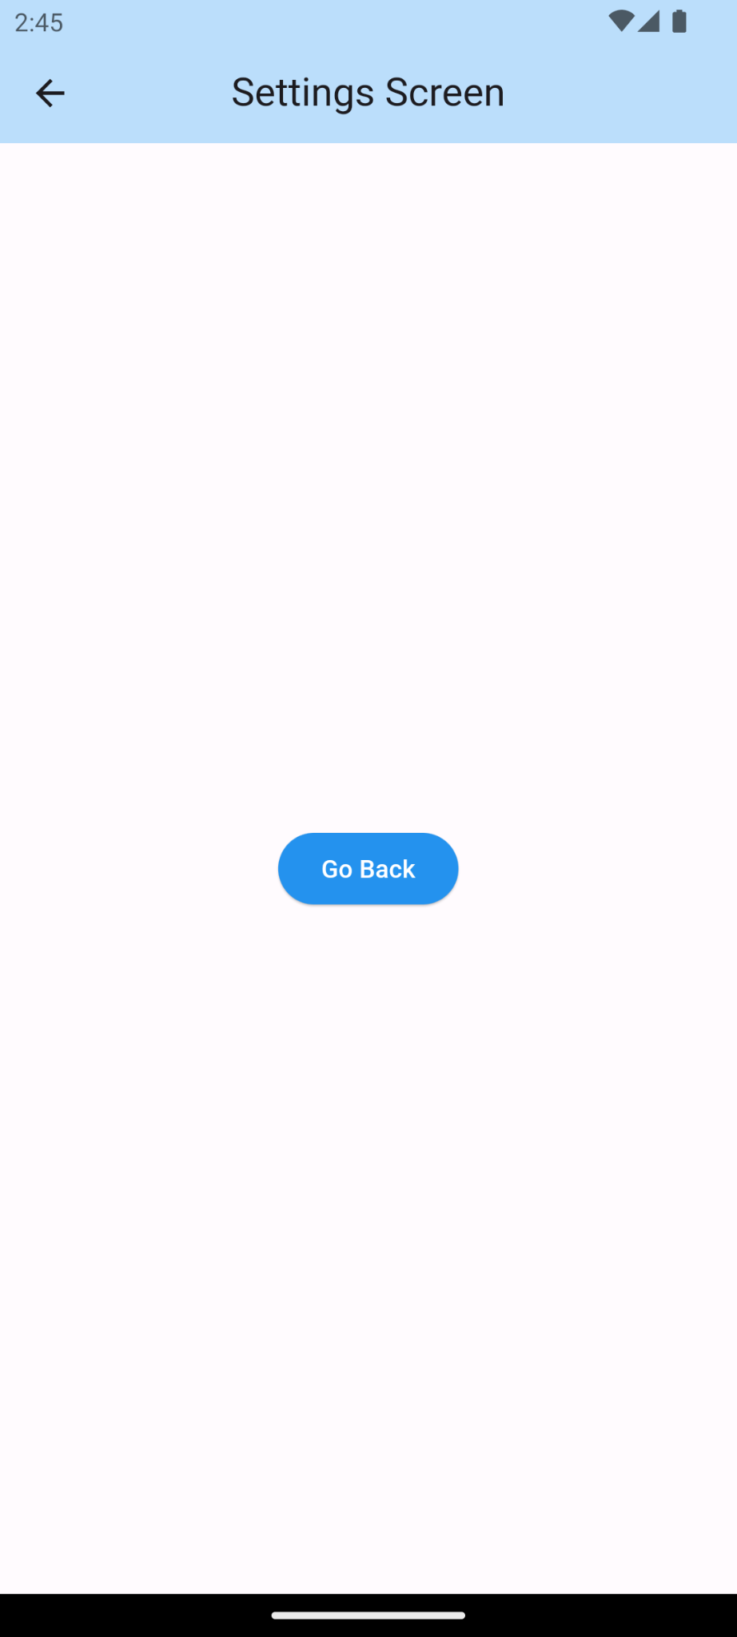

# **How to submit your workshop**

Push your project back to the same git branch using command:

<command name>

# **Happy Coding!**